Children and Young People Services (CYPS)
Neurodevelopmental Team
Post-Diagnostic Pack for Parents and Carers of a Child or Young Person with Autism Spectrum Condition (ASC)


Surrey and Borders Partnership NHS

Introduction
This resource pack has been designed for families with a child who has received a recent diagnosis of Autism Spectrum Condition (ASC).
There is increasing awareness, understanding and acceptance of ASC and a number of sources which you can turn to for help and advice. Although there is a wealth of information available about ASC, it can be overwhelming in the beginning to find material that is most useful for you. This resource pack has been created to help act as a starting point in your family’s journey.
This resource pack features links to different kind of support, some of which can be accessed locally, nationally, or online. There is also information relating to strategies and teaching approaches which may be helpful.
Every autistic person is different and therefore it will be up to you and your child to decide what from this pack is appropriate for the individual needs of your family.

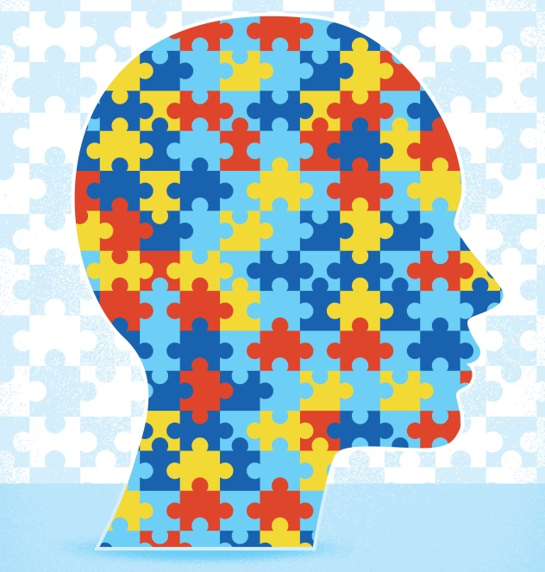

What is ASC?
Autism Spectrum Condition (ASC) is a lifelong neurodevelopmental condition that affects social interaction and communication skills. Although autistic people all share two main areas of difficulty, their condition may affect them in very different ways and to varying degrees.
The two main areas of difficulty that all autistic people share are:
- Difficulty with social communication and social interaction

- Restricted interests and repetitive behaviours

Some autistic people may also present with other developmental difficulties. For example, they may have learning difficulties (e.g. dyslexia) or a learning disability, which can range from mild to moderate or severe. ASD can also sometimes occur in conjunction with other neurodevelopmental conditions such as Attention Deficit Hyperactivity Disorder (ADHD).
The causes of autism are still being investigated. Many experts believe that the patterns of behaviour from which autism is diagnosed may not result from a single cause. There is evidence to suggest that autism can be caused by a variety of physical factors, all of which affect brain development. There is also evidence to suggest a significant genetic component in autism. However, this is still under further scientific investigation. We know that autism is not caused by:
- bad parenting
- vaccines, such as the MMR vaccine
- diet
- an infection you can spread to other people

Looking to the future
Receiving a diagnosis of autism can help open up access to appropriate services and support. ASC is a dynamic disorder that may present differently at various times throughout life, and it can be influenced by a child’s developmental stage and wider contextual factors. Times of stress or transition, or situations that require substantial changes in routine can be difficult for all of us, and these times can be particularly difficult for a autistic person. It is important to recognise that in many cases, changes in your child’s behaviour may not necessarily indicate that something is ‘wrong’, or that their ASC is getting worse, instead it can be a reflection of the impact of changes to the child’s environment or routine.
As your child grows, their skills, understanding and use of communication and appropriate social behaviour may change through teaching and support. They may also develop various strategies to mask or compensate for their difficulties.

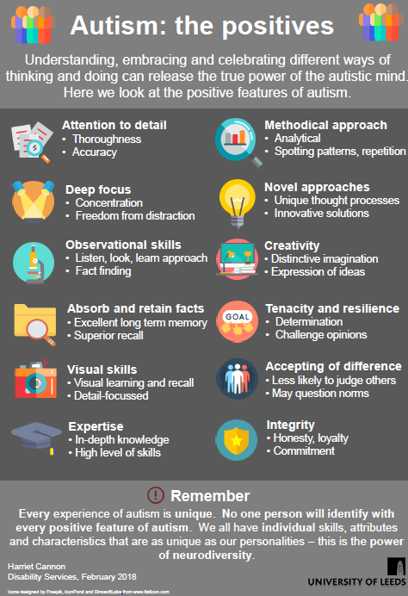

How Can Parents Help?
As parents and carers, you are in the best position to be able to help and support your child, as you know them best.
As with any child, the need for support and love from parents and family members is vitally important. Your child has the same physical and emotional needs as other children, however you may have to adapt the way in which you express your love and concern, to fit in with your child’s needs and perspective.
As a parent or carer, you will already have a lot of the skills required to help your child. You can develop additional skills required for supporting your child by watching how they respond to situations, learning to adapt things which cause them difficulties, and helping them to develop techniques and coping strategies.
In many areas of the UK, support groups, workshops and programmes have been set up specifically for parents to provide advice and information. These focus on developing communication skills, understanding behaviour and developing attention, work and play skills.
It is also important to ensure that you consider your own wellbeing in conjunction with supporting your child.



Tips and Strategies For Supporting Young People With ASD
The below tips and strategies provide a toolkit of possible approaches. Some of them may work whilst others may not and it will be a process of discovering what works best for you and your child in different situations and at different times.

General advice
- Try to create a secure, predictable, structured environment
- Use visual supports to provide preparation (e.g. photos of new places, visual timetable of daily activities)
- Enjoy your child’s strengths and interests
- Give small, easily achievable responsibilities to help raise self-esteem
- Find ways of having fun together
- Find your own support network

Social Communication
Adapt your language:
Use your child’s name at the start of the sentence so that they know that what you are about to say is relevant to them
Slow down your rate of speech and add more pauses
Don’t give more than one piece of information at at time

Explain implied meanings, sayings,metaphors and sarcasm

Be specific about time expressions, but bear in mind these might be taken literally e.g. I’ll be with you in 5 minutes (rather than later or in a while)

Support Communication and Interactions:
Encourage your child to use all forms of communication to express their needs, ask for information or to share difficult feelings -e.g. spoken words /written notes/drawings/text messages/email
Recognise that your child might find it difficult to join in conversations, particulary with unfamiliar people. Help them to agree with their teacher /club leader the best way for them to join in or ask for help e.g. putting hand up, holding up a visual cue card, walking over to a supportive adult.
Choose social situations carefully, take into consideration the length of time or how many people will be there
Allow your child time and space to rest after social interactions with others. Give time to decompress at the end of the school day before asking any questions about your child’s day.
Teach your child how to play some simple games (such as card games like Uno or Dobble, or Orchard games). This teaching can include following the rules of the game and learning to accept winning or losing. It may be helpful for your child to practice these skills with an adult initially and then play with other young people.
Structure play dates (if your child would like to have peers to play) by setting up an activity that you can join in with e.g. icing cakes, making playdough, playing a game.
Be aware that your child may be vulnerable to bullying or rejection by peers, particularly as they get older. Adults will need to provide appropriate supervision and be vigilant regarding when it may be necessary to intervene.

Managing change
Provide preparation prior to new activities or changes to the everyday routine.
- Use photos or video clips to prepare for new places
- Use Social StoriesTM to provide information about what will happen during a specific event.
- A visual timetable (with words, line drawings or pictures) can be used to outline daily activities e.g. breakfast, park, lunch, swimming, dinner, bath, story, bed. You can tick off each activity once it has been finished.
It may help to introduce the use of timers (such as sand timers, kitchen/phone timers, or your own smart home devices) within the daily routine. These can be used to indicate that something needs to finish. It can be helpful to include the child in the setting of the timer so that they are prepared for it to go off.

Understanding Emotions and Emotional Regulation
Your child may require support to enable them to identify and express their own emotions and to understand the emotions of others. Their school should be able to share helpful resources to help with this. The following resources may also be helpful:
  - The Zones of Regulation http://www.zonesofregulation.com/learn-more-about-the-zones.html
  - When My Worries Get Too Big by Kari Dunn Buron
  - The Incredible 5 Point Scale https://www.5pointscale.com/

Sensory Needs
Children with ASD often have sensory sensitivities, and can over or under sensitive to sensory input (e.g. touch/sound/light/pain/taste). They may also struggle to recognise their internal body signals (e.g. hunger/thirst/temperature).
- Your child may benefit from having a sensory box at home and at school, filled with sensory objects they like to engage with.
- It may also be helpful to think about environmental adaptions necessary to reduce the impact to sensory sensitivities. For example, if your child finds the noises in the school hallways overwhelming, discuss with teachers if they could leave lessons two minutes early so they have the chance to get to their next lesson while the hallways are still quiet. This is just an example and it will be important to speak to your child to ascertain what adaptations may be useful for them.
- Your child may benefit from having further assessment with an Occupational Therapist. A referral for this can be made via their GP or school, if required.
- Additional self-help resources in relation to Occupational Therapy support can be found online: https://childrenshealthsurrey.nhs.uk/services/occupational-therapy Useful links to websites, apps, shops, and the advice sheets about senses and school resource packs, which also include relevant sections for parents to read, can be found on the right-hand side of the website.


Local Services

There are many different services which are available locally to help support and advise your child and yourself. Below is a selection of some which are available, but more can be found by searching on the NAS Autism Services Directory.
Surrey-Wide
Parent carers
Website: https://www.surreycc.gov.uk/adults/care-and-support/carers/parent
A parent carer is entitled to a Carers Assessment to find out what help they need and how these needs can be met. This should mean support and help for you as a carer, and recognition of your role in your child's life.
Being a parent carer can sometimes be a difficult task and there is a variety of support available, including breaks and respite support.
Please look at the Surrey County Council website to find out how to request a Carer’s Assessment and the support available.

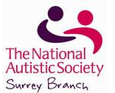
NAS Surrey Branch
Website: www.nassurreybranch.org
Email: NASSurreyBranch@NAS.org.uk
Telephone: 07423435413
The NAS Surrey Branch is a volunteer-run support group with over 1500 members. They offer a variety of local meetings, talks, parent programmes and activities for families with autistic individuals. They publish a newsletter which is sent to members every two months, and it includes details of upcoming events. It is free to join the group.

NAS Surrey CLUBS FOR CHILDREN & YOUNG PEOPLE
Website: https://nassurreybranch.org/nas-clubs-for-children/
Email: SEresourcecentres@nas.org.uk
Telephone: 01483521743

The NAS Surrey Autism Resource Centre currently runs a multitude of term-time groups across Surrey including children’s clubs in Godalming, Reigate, Walton and Woking, youth clubs in Staines, Reigate, Epsom, Ash and Guildford, and social skills groups in Godalming and Guildford. In order to attend, parents or carers must complete a self-referral form which they can obtain by emailing the account above.

NAS Surrey Branch Meetings
Website: https://nassurreybranch.org/surrey-branch-meetings/
There are many group meetings being held around Surrey. These include local support group meetings, evening talks, pub meetings, parents/carers of girls groups and dads groups. To join your local group, please visit the website listed above and contact the relevant person.

NAS Surrey Branch EarlyBird Team and Teen Life Team
Website: https://www.autism.org.uk/what-we-do/support-in-the-community/family-support
Email: earlybird@nas.org.uk
lcooper@freemantles.surrey.sch.uk
pleach@freemantles.surrey.sch.uk
Telephone: 01226779218 or 01483 545 680
EarlyBird (under five years), EarlyBird Plus (ages four-nine), Healthy Minds and Teen Life (ages 10 to 16) are support programmes for parents and carers, offering advice and guidance on strategies and approaches to working with young autistic children. The programmes work on understanding autism, building confidence to encourage interaction and communication, and understanding and supporting behaviour.


Surrey Young Carers
Website: http://www.surrey-youngcarers.org.uk/
Email: CarerSupport@actionforcarers.org.uk
Telephone: 0303 040 1234
Surrey Young Carers supports young carers within Surrey that are aged below 18 years old. They offer many different types of help and support, including: one to one support, talking to others on your behalf, offering groups and workshops, residential breaks and support with school or college. They also have a regular newsletter which is sent to people accessing their services, and post information online on their website and on their Twitter account.

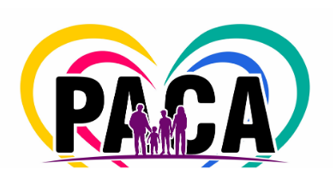
Parent and Carer Advisors (PACA)
Website: https://www.surreysays.co.uk/csf/parents-carers-paca/
Facebook: Search ‘PACA Surrey’
PACA is a participation and support group, facilitated by the User Voice & Participation Team, for parents and carers whose children or young people access Emotional Well-being Mental Health or Special Educational Needs and Disabilities (SEND) services in Surrey. More information is available on their websites.

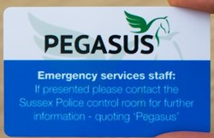
Pegasus Card, Surrey
Website: https://www.surrey.police.uk/contact/af/contact-us/us/contact-us/sspegasus-scheme/pegasus-card-scheme/
People with a learning disability or those who find it difficult to communicate can register with Surrey Police's Pegasus scheme. The Pegasus database stores people's details, meaning those who may have difficulty giving their name and address when making contact are supported. Registering means that police staff can identify the person easily and that the person can quickly get on with telling the police why they made contact. When people register with Pegasus, they are given a Personal Identification Number (PIN). They use this when calling the Police, who can then find their details easily. People are also given a Pegasus card for when they need to talk to the Police in person. Showing their card to a police officer, member of police staff or other emergency services staff will ensure that they know the person may need additional help and support.


CYPS ASD Parent Support Group.
This group is organised by CYPS and runs on a monthly basis. Sessions are between 9.30-11.30am, in Gatton Place, St. Matthews Road, Redhill, RH1 1TA. For further information please contact Redhill CAMHS on 01737 288700. Previous sessions have focused on topics such as low mood, aggressive behaviour, and Pathological Demand Avoidance.
Parents/carers can join a local support group for parents and carers of children with special educational needs or neurodevelopmental conditions such as ADHD and ASD. This group is held at 8pm on the 1st Tuesday of every month at the Ship Inn in Farnborough. For more information, please visit: http://www.braain.co.uk/
The NAS Surrey Branch also runs parent-to-parent support groups. These groups provide information about ASD as well as free workshops and seminars for parents/carers. Previous workshops have covered topics such as ‘Supporting your child with transition stages at school’ and ‘Understanding and managing behaviour’. For more information please refer to your resource pack.
ND helpline
Neurodevelopmental Team (Non-Urgent admin and duty requests) Monday-Friday (9am- 5pm) We aim to respond within 72hours Please allow 10 days for prescription requests ND Phone line: 01372 216 555 (Mon-Fri 9am-5pm) ND Freephone Helpline (Out of Hours): 0300 222 5755 (5pm-11pm 7 days a week) Please access: www.mindworks-surrey.org in the interim for more information. Crisis Information If you or someone else in in a life threatening situation please call 999 immediately 24/7 CAMHS Crisis Line: 0800 915 4644 (Option 1) (for children, young people, families and carers in Surrey)
For more info: https://www.sabp.nhs.uk/our-services/advice-guidance/getting-help-crisis
Mindworks Surrey (mental health)
An emotional wellbeing and mental health service for children and young people in Surrey.
www.mindworks-surrey.org.uk
Learners' Single Point of Access (L-SPA) | Surrey Local Offer
The Learners' Single Point of Access (L-SPA) offers help and support if you have a concern about the development and/or learning needs of a child in Surrey.
Both parents and practitioners working with children in Surrey are welcome to call the L-SPA.
It is open from 9am to 5pm, Monday to Friday, all year round (except Bank Holidays) on 0300 200 1015. For more info www.surreylocaloffer.org.uk/lspa

Children and Family Health Surrey
Children and Family Health Surrey is the Surrey-wide NHS community health service for
children and young people from birth up to 19 years of age and their parents and carers.
This website contains helpful resources for services including occupational therapy and speech and language therapy. www.childrenhealthsurrey.nhs.uk
Parent Voice Surrey
Family Voice Surrey champions the needs and rights of SEND families in Surrey: families with children or young adults up to the age of 25 who have special educational needs, chronic illnesses, including mental health conditions, or disabilities.
For more info www.familyvoicesurrey.org
Appeer
Appeer are a not for profit organisation run to benefit autistic girls and women, and those around them.
Online and in-person Sessions and Programmes which support A Positive PEER approach, through which autistic Girls, Teens and Women and their Parents/Carers can connect through sharing interests and receiving support.
For more info www.appeer.org.uk

West Surrey
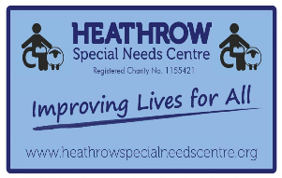

Heathrow Special Needs Centre
Website: www.heathrowspecialneedscentre.org
Email: info@heathrowspecialneedscentre.org
Telephone: 01753 680330
Heathrow Special Needs Centre is a local charity which was formed in 1986 to promote animal and gardening therapy for people with disabilities and special needs. The charity is home to over 70 animals, including horses, pigs, sheep and chicken. There is also a sensory garden, horse riding, purpose built raised vegetable and plant gardens and a non-profit café.


A SPace Autism Services
Website: www.aspaceautismservices.weebly.com
Email: ateam_aspace@yahoo.co.uk
Telephone: 07487 636 838
A SPace Autism Services provide social skills group for autistic children and young people. They aim to teach social and emotional development skills in an environment which is different to formal teaching and schools. They do this by providing a safe space for the children and young people to address their feelings and emotions, whilst feeling supported. There are different groups aimed at certain ages. The groups run fortnightly for six sessions.


Mustard Seed Autism Trust
Website: www.mustardseedautism.co.uk
Email: info@mustardseedautism.co.uk
Telephone: 07980 636413
Mustard Seed Autism Trust was set up in 2011 as an organisation to provide a professional service in the community to families living with autism. They provide a free service to children aged between 3 and 11, whom live within a 10 mile radius of Farnborough. They provide support with communication, social, sensory and anxiety issues, as well as advice on daily routines, behaviour, play, self-help skills and accessing the community. Their services also include play therapy, sensory therapy and family support.


East Surrey

Autism All Stars
Website: https://autism-all-stars.org/

Autism All Stars is a local charity which was founded by a mother of four autistic children. The charity aims to raise awareness of ASD and its related conditions, to provide support for people both with and without a diagnosis, and to provide a space for autistic people to meet like-minded people and to help them feel included in society. They also aim to educate parents and carers and campaign for greater acceptance of ASD. They regular hold events including a monthly ASD friendly film club in Crawley.

Carers’ Support Mole Valley
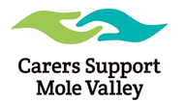
Website: https://www.molevalley.gov.uk/home/community/adult-care-support
Email: info@molevalley.gov.uk
Telephone: 01306 885001
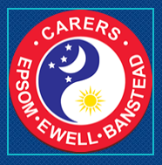
Carers Support can help carers from all communities across Mole Valley by providing practical information and emotional support. Their services include carer advisers and an emotional support service. They can also provide information on local and national services available for carers and for the people they care for.

Epsom

Carers of Epsom
Website: www.carersofepsom.co.uk
Carers of Epsom is an independent organisation offering free active support and moving and handling advice for carers. The Carer Support Workers offer emotional support, contact with others, social activities, information, assistance and advocacy.

National Resources
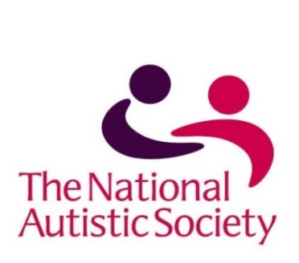

National Autistic Society (NAS)
Address: 393 City Road, London, EC1V1NG
Website: www.autism.org.uk
Email: nas@nas.org.uk
Helpline: 08450704004 (Monday to Friday, 10am – 4pm)
Calls charged at local rate
The NAS is the UK’s leading organisation for autistic people and their carers. Its aim is to champion the rights and interests of all autistic individuals and to provide them and their families with help, support, and services that they can access, trust, and rely upon and which make a positive difference to their lives. The website has a wealth of information for autistic people, their families, and professionals. This includes: definitions of ASD and Asperger’s syndrome, information sheets on a variety of topics, and personal accounts by autistic people, their parents/carers, and siblings.
Other NAS web services that may be of interest are:
- Autism Advice and Guidance
  - Advice and guidance on a wide range of information about autism – from what autism is, to diagnosis, to socialising and relationships.
  - https://www.autism.org.uk/advice-and-guidance
- Autism Services Directory
  - This is designed to help autistic people, their families and the people who work with them professionally to find out more about the services available to them
  - It draws from a UK-wide database of diagnostic services, schools, support groups, training courses, residential and day services and much more
  - Through simple searches and browsing (by area or service category), users will be able to find their nearest school, adult centre, respite service, play scheme or other type of local or national service
  - https://www.autism.org.uk/directory

Contact a Family

Address: 209-211 City Road, London,
EC1V1JN
Email: helpline@contact.org.uk
Website: https://contact.org.uk/
Telephone: 0808 808 3555
Contact a Family is a UK-wide charity, providing support, advice and information for families with disabled children.
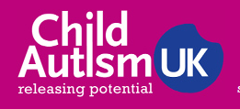

Child Autism UK
Website: www.childautism.org.uk
Telephone: 01344 882248
Child Autism UK provides services and advice for families of autistic children. These services include teaching children social skills, helping to reduce their anxiety and providing Applied Behaviour Analysis (ABA) training for parents and carers.

Ambitious About Autism
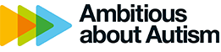
Website: www.ambitiousaboutautism.org.uk
Email: info@ambitiousaboutautism.org.uk
Telephone: 020 8815 5444
Ambitious about Autism are a national charity for autistic children and adolescents. They provide services, raise awareness and understanding, and campaign for change. Their vision is to make the ordinary possible for autistic children, and their mission is to help them to learn, thrive and achieve.


SOS SEN
Website: www.sossen.org.uk
Telephone: 02085383731
SOS SEN is an independent telephone helpline for parents and others looking for information and advice about Special Educational Needs (SEN). Support is centred on the legal and procedural processes that are associated with finding provision for children with SEN.


Scope
Website: www.scope.org.uk
Email: helpline@scope.org.uk
Telephone: 08088003333
Scope is a charity with the aim ‘to drive change across society so that disabled people have the same opportunities as everyone else’. They provide support, information and advice to more than a quarter of a million disabled people and their families every year. The website has areas exploring ASD and the various support available to autistic people and their families. For young people approaching the age where they may be seeking employment, Scope provide guidance and advice on gaining employment and the rights of emloyees with additional needs.

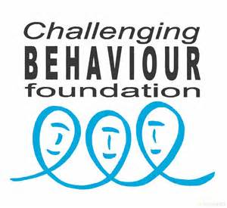
Challenging Behaviour Foundation
Address: The Old Court House, New Road Avenue,
Chatham, Kent, ME46BE
Website: https://www.challengingbehaviour.org.uk/
Email: support@thecbf.org.uk
Telephone: 03006660126
The Challenging Behaviour Foundation offers information about challenging behaviour to anyone who supports someone with a severe learning disability. They provide information on a range of topics, including: responding to challenging behaviour, education, exclusion, mental health, safeguarding and transition.

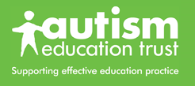
The Autism Education Trust (AET)
Address: AET, c/o National Autistic Society,
393 City Road, London, EC1V1NG
Website: www.autismeducationtrust.org.uk
Email: info@autismeducationtrust.org.uk
Telephone: 02079033650
The AET is a government funded organisation which aims to co-ordinate and improve educational support for all children on the autism spectrum. It gives advice on everything from support in schools to respite breaks.


The Department for Work and Pensions
Website: www.gov.uk/browse/benefits/disability
Telephone: 03457123456
The Department for Work and Pensions will be able to advise you about the various benefits you may be able to apply for, including Disability Living Allowance. This is a weekly tax-free benefit paid to help with the extra costs of bringing up a child who has special needs.


The Family Fund
Address: 4 Alpha Court, Monks Cross Drive,
York, YO329WN
Website: www.familyfund.org.uk
Telephone: 08449744099
The Family Fund is a charity which gives financial help to families with severely disabled children. This includes financial support for holidays, sensory toys, tablets and computers, clothing and kitchen appliances.
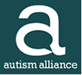

Autism Alliance
Website: www.autism-alliance.org.uk
Autism Alliance is a major UK network of specialist autism charities. They support thousands of autistic individuals, through both residential homes and outreach. They also run schools for autistic children and provide training for staff in the public and private sector. They passionately believe that autistic people should develop their full potential, and they believe that having specialist ASD knowledge and early specialist intervention, they can work towards that goal.

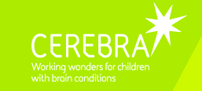
Cerebra
Website: www.cerebra.org.uk
Email: enquiries@cerebra.org.uk
Telephone: 01267 244200
Cerebra is a unique charity which aims to help improve the lives of children with brain related conditions through research, education and directly supporting the children and their carers’. They provide patient friendly information and guidance for families and professionals, give advice about welfare rights and benefits and run academic research programmes.

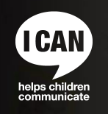
ICAN
Address: Unit 31, Angel Gate (Gate 5), Goswell Road,
London, EC1V2PT
Website: www.ican.org.uk
Telephone: 020 7843 2544
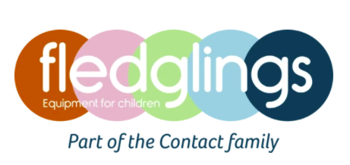
ICAN is a charity for children with speech, language and communication difficulties. It can provide an online resource of information, knowledge and ideas, including DVDs and practical help for families via the website.

Fledglings
Website: www.fledglings.org.uk
Telephone: 0203 319 9772
Fledglings are a charity which helps to source and supply specialist pieces of equipment for families with children with special needs. They sell products via their brochure which can be accessed online or can be sent to a home address. They also have a helpline which parents and carers can call to get advice on which products may suit their child and family best.

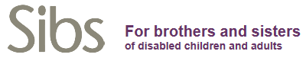
Sibs
Website: www.sibs.org.uk
Sibs is the only UK charity which represents the needs of siblings of disabled people. Siblings have a lifelong need for information, and they often experience social and emotional isolation and are made to cope with difficult situations. They want to have positive relationships with their disabled brothers and sister and want to be able to choose the role that they play in future care and support. Sibs aims to enhance the lives of siblings by providing them with information and support, and by influencing service provision through the UK. Sibs support adult siblings and Young Sibs.


Kids
Website: www.kids.org.uk
Kids is a charity which supports over 8000 disabled children, young people and their families every year by delivering around 125 services across England. Some of the services that they offer include supporting the development of skills in parents and carers and children and young people. They also provide short breaks and respite opportunities for children and young people, and hold activities for siblings.

Helpful Website Addresses

NAS Autism Services Directory
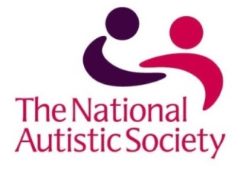
Website: www.autism.org.uk/directory.aspx
An online service provided by the National Autistic Society which has a search facility for local services, including practical or emotional support, education, assessment, advice and advocacy.


Research Autism
Website: https://researchautism.org/
Research Autism is the only charity in the UK that is dedicated to research into interventions in ASD. Their website is aimed at anyone with an interest in research into ASD; including autistic people, their parents and carers, service providers, policy makers and professionals.

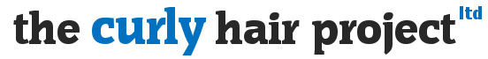

The Curly Hair Project
Website: www.thegirlwiththecurlyhair.co.uk
The Curly Hair Project aims to improve understanding and communication between woman and autistic girls and their family. The website has links to seminars and talks which are held across the country, and has an online shop where resources can be purchased.

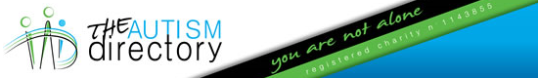

The Autism Directory
Website: https://www.theautismdirectory.com/
The Autism Directory is an online directory website which provides a search facility to allow site-users to access information in various areas, such as health, education, treatments and therapies, personal support, living support, money and legal, recreation and holidays, books and magazines and ASD friendly businesses.

Ambitious about Autism Youth Network
Website: https://www.ambitiousaboutautism.org.uk/get-involved/join-our-youth-movement/ambitious-youth-network
The Ambitious Youth Network is an online platform that connects young people aged 14-25 with other autistic young people on the network, Ambitious about Autism youth patrons and young people involved with the Autism Education Trust. It is a place to talk to other autistic young people, find out about employment opportunities for autistic young people and keep up to date with opportuinities. Some companies have specifically partnered with Ambitious about Autism to provide work experience and job opportunities for autistic young people, to try and make their workplaces more inclusive.

Other Resources

There is a large selection of books written for parents/carers, autistic children and their siblings. The main publishers in the UK are the National Autistic Society (020 7833 2299 https://www.autism.org.uk/)and Jessica Kingsley Publishers (020 7833 2307 www.jkp.com).

Books for autistic children
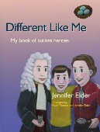
Elder, J. ‘Different Like Me: My Book of Autism Heroes’
Different Like Me introduces children aged 8 to 12 years to famous, inspirational figures from the world of science, art, math, literature, philosophy and comedy.
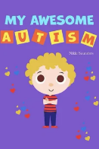
Saunders, N. ‘My Awesome Autism’
A book to help empower children and to highlight just how brilliant they are for being themselves!

Cummins, L. (2019) ‘A Different Kind of Brilliant’
Written by a Mum to help teach her son with autism to embrace his differences and recognize he is a different kind of brilliant. This book will help children understand what autism is and learn how many successful people have used their uniquely wired brains to change the world for the better.It will also help children to better understand and support autistic classmates or siblings and also promote discussion and understanding about celebrating differences.
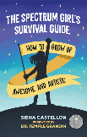
Castellon, S. (2020). The Spectrum Girl's Survival Guide: How to Grow Up Awesome and Autistic.
This essential go-to guide gives you all the advice and tools you'll need to help you flourish and achieve what you want in life. From the answers to everyday questions such as 'Am I using appropriate body language?' and 'Did I say the wrong thing?', through to discussing the importance of understanding your emotions, looking after your physical and mental health and coping with anxiety and sensory overloads, award-winning neurodiversity campaigner Siena Castellon uses her own experiences to provide you with the skills to overcome any challenge.

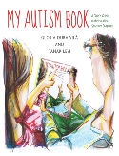
Dura-Vila, G. and Levi, T. (2013) ‘My Autism Book, A Child's Guide to their Autism Spectrum Diagnosis’
This illustrated book is tailored to the needs and experiences of autistic children aged 5 and up; it explains what an ASD diagnosis means and encourages an exploration of the child's strengths and differences.

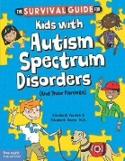
Verdick, E. (2012) ‘Survival Guide for Kids with ASDs’
This positive, straightforward book offers autistic children their own comprehensive resource for both understanding their condition and finding tools to cope with the challenges that they face every day.

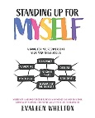
Whelton, E. (2022) ‘Standing Up for Myself: An Empowering book for Neurodivergent kids and teens about boundaries, sensitivity, personal space, consent, power play and self advocacy’
Heartfelt and positive messages for Autistic kids and teens aged 9 to 15 years
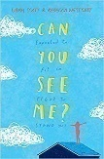
Scott, L. and Westcott, R. (2019) ‘Can You See Me? A powerful story of autism, empathy and kindness’
This fictionalised portrayal of a young autistic girl is written by Rebecca Westcott, in close collaboration with Libby Scott, making it a truly original and inspirational book that will give readers of all ages a deeper understanding of what it's like to be autistic.

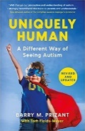
Prizant Ph.D, Dr. Barry M., Fields-Meyer, (2022) ‘Uniquely Human: A Different Way of Seeing Autism’
Autism is a different way of being human. By understanding autistic behaviours as strategies to cope with a world that feels chaotic and overwhelming, Barry Prizant seeks to enhance abilities, to teach new skills, help individuals build on their strengths and develop coping strategies to achieve a better quality of life.
Books for Siblings

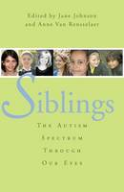
Johnson, J. (2010) ‘Siblings: The Autism Spectrum Through Our Eyes’
This book is a collection of personal stories written by the siblings of autistic people, written to be shared with other siblings. The stories offer empathy, constructive advice and reassurance that occasional feelings of resentment and embarrassment are normal.

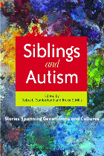
Cumberland, D. L. (2010) ‘Siblings and Autism: Stories Spanning Generations and Cultures’
This book contains personal accounts of growing up with an autistic sibling. The stories come from siblings from a variety of backgrounds and in different circumstances.


Brock, C. (2010) ‘I’m a Teenager Get Me Out Of Here!: A Survival Guide for the Teenage Siblings of Young People with Autism’
A book written for teenagers with an autistic sibling.

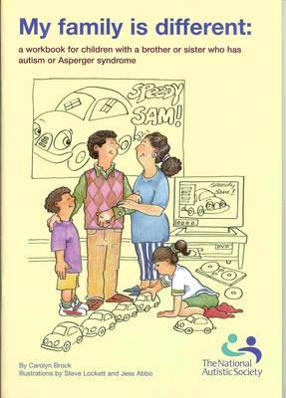
Brock, C. (2016) ‘My Family is Different’
Sold by the NAS – product number NAS1003
This colourful workbook is aimed for young children aged five to eight. It is full of activities and games to help siblings understand their autistic siblings.

Books for Parents or Carers

Sophie Koborg-Brosen (2006) ‘Do you Understand Me?: My life, my thoughts, my ASD’
Teachers, parents, carers, support workers, children with autism spectrum disorders and their classmates will find this an entertaining, informative and attitude-changing read.

Pascuas, C. (2016) ‘The Autism Activities Handbook: Activities, to Help Kids Communicate, Make Friends and Learn Life Skills’
This book offers strategies and ideas to enrich the lives of autistic children through meaningful activity. There are more than thirty games and activities included.

Hudon, S (2016) ‘Autism: Everything You Need To Know About Autism – Autism Signs, Symptoms, Causes, Treatments and Therapies!’
This book is a guide for the parents of children and young autistic people. It aims to help parents understand their roles better. Topics that are explored include the signs, symptoms causes, behaviour and treatment of ASD.

Elliot Price, S. (2015) ‘Autism Explained: How an Autistic Child Can Learn To Thrive In a World That Doesn’t Understand’
This book has tips, techniques and stories that aid understanding regarding what a child with ASD is experiencing. The book discusses practical ways to help autistic children, discussing treatment, what a diagnosis means, how to create a structured routine, coping techniques and effective communication strategies.

Notbohm, E. (2012) ‘Ten Things Every Child with Autism Wishes You Knew’
This revised version of the bestseller, describes ten characteristics that help to illuminate – not define – autistic children.

Bogdashina, O. (2016) ‘Sensory Perceptual Issues in Autism and Asperger Syndrome, Second Edition’
This updated version of the book focuses on sensory perceptual problems as identified by autistic people. Assessment, intervention and practical recommendations are discussed.

Pike, R. (2016) ‘Autism: Talking About a Diagnosis’
Sold by the NAS – product number NAS1002
This book for parents and carers of autistic children, explains the key things to think about when preparing to talk to your child about their ASD diagnosis.

Hattersley, C. (2013) ‘Autism: Understanding Behaviour’
Sold by the NAS – product number NAS969
This book helps parents and carers to understand the cause and function of their child’s behaviour. There are also practical strategies discuss to help manage a child’s anxiety and stress.

Powell, A. (2013) ‘Autism: Understanding and Managing Anger’
Sold by the NAS – product number NAS948
This book discusses why autistic children can become angry and includes practical ways to help, including preventing and manager anger, coping with meltdowns and helping manage a child’s feelings.

Hattersley, C. (2014) ‘Autism: Supporting Your Teenager’
Sold by the NAS – product number NAS1000
This book includes advice and suggestions on how to support a young autistic people through the challenges of teenage life. It also includes resources, activities and exercises.

Dickenson, P. and Hannah, L. (2014) ‘It Can Get Better’
Sold by the NAS – product number NAS284
This pocket sized book is written by health professionals who have experience supporting autistic children who display challenging behaviour. The book explores common behaviour problems and offers strategies and tips on how to deal with them. It covers topics including temper tantrums, toileting, and feeding among others.

Dundon, R. (2019) ‘The Parents’ Guide to Managing Anxiety in Children with Autism’
Sold on Amazon – search ‘anxiety and asd’
This guide for parents is a complete introduction to autism and anxiety. Drawing on the author's clinical experience working with children and their families, it provides parents and carers with everything they need to know to help support their child. It covers the basics such as what anxiety is, how it manifests behaviourally and why it is common in autism, before presenting CBT-informed practical strategies for managing a common range of anxieties: separation, social, performance, phobias, and generalised anxiety. It also has chapters dedicated to related behaviours including Pathological Demand Avoidance (PDA) and advice on managing meltdowns. This is a clear, concise and practical guide that answers any questions that parents and carers might have about anxiety and provides support strategies to help children with autism manage a range of anxieties.



Online films and documentaries regarding ASD
- An online documentary called ‘Being Different May Be Cool’ following the learning experiences of three autistic brothers
https://www.tes.com/teaching-resource/teachers-tv-being-different-may-be-cool-6083375
- An online documentary called ‘Secondary SEN – Understanding Autism’ looking at how life can be for autistic people in secondary school
https://www.tes.com/teaching-resource/teachers-tv-secondary-sen-understanding-autism-6049006
- Links to films and documentaries about ASD:
https://www.autismspeaks.org/family-services/resource-library/films-and-documentaries
- A YouTube link to the award winning documentary ‘My Autism And Me’
https://www.youtube.com/watch?v=ejpWWP1HNGQ
- A Youtube link to an amination about autism ‘Amazing Things Happen’ by Alexander Amelines
https://www.youtube.com/watch?v=RbwRrVw-CRo
- A Youtube link to Neurodiversity Explained – A video explaining neurodiversity using Lego.
https://www.youtube.com/watch?v=b3rj9nUv0Qg
- A link to the YouTube channel of Amythest Shaber who has a popular series called ‘Ask An Autistic’
https://www.youtube.com/user/neurowonderful

Contact Details:

CYPS Neurodevelopmental Service
Telephone Number: 01372 216 555

Opening Times: Monday - Friday, 9am - 5pm

ND out of hours helpline: 0300 222 5755

Created by Simran Dhaliwal and Hanna Clarke (Assistant Psychologists); updated by Solin Hamawandy and Molly Foster (Assistant Psychologists) July 2020 and Kate Altham (Assistant Psychologist) November 2021, under the supervision of Dr Jessica Howse and Dr Monika Kempa (Clinical Psychologists). Updated March 2023.

